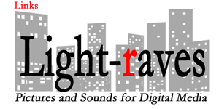

Some useful Internet links:

Language Translator:
/mobile: Google online translator
/app: http://www.google.com/mobile/translate/

Weather:
/www.nws.noaa.gov
/www.worldweather.org
/mobile: http://mobile.weather.gov/
/mobile: http://foreca.mobi/

Travel:
/International Travel, Passports & Visas, Travel Advisories: www.travel.state.gov
/mobile Flight times & status: http://mobile.flightstats.com/go/Mobile/home.do

News:
/mobile Boston Globe: http://www.bostonglobe.com/
/mobile BBC news: http://m.bbc.co.uk/news/

Website Search Engines:
/mobile www.lycos.com: http://www.lycos.com/
/mobile site search: http://jumobi.com/

Misc:
/Visionairies: http://www.visionaries.org

©2012 www.light-raves.com / (781)883-5300 / bruce@light-raves.com

